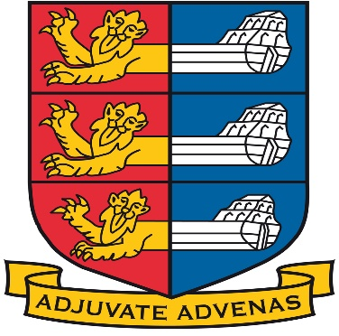
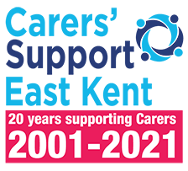

The Worshipful Mayor of Deal

Cllr Chris Turner

Invites you to a private guided tour of
DEAL CASTLE
On Friday 29th April at 5.30pm
Followed by
Fish & Chips
In Deal Town Hall
In aid of
Carers Support East Kent
&
The History Project
£15 per head
To book a place and for more details please contact
una.finch@deal.gov.uk
Deal Castle Private Tour & Supper

English Heritage Guides will begin the estimated one hour tour, at 5.30pm which covers all 3 floors of the castle built by Henry VIII nearly 500 years ago. From the top floor with its imposing view of the English Channel to the cold, damp tunnels that lie beneath. Recalling the history of the Civil War through to WW2, revealing the secrets and scars the castle holds. As the guides walk through the castle’s story, they will define how Deal has grown into the town we see today around the foot of the castle.
There may be areas that some guests will find challenging on the tour. We suggest they sit and admire the English Channel and the view of Deal’s popular promenade and the pier.
Following the tour, the mayor will take his guests back to the Town Hall for a Fish & Chip supper and a glass of wine.
This will be the Mayor’s farewell to his Civic Year in Office and he is hoping to show his guests one last night of hospitality in Deal, whilst raising money for his 2 deserving local charities.
Guests meet at 5.15pm in Deal Castle Car Park Victoria Road Deal CT14 7BA
Chains of office are invited to be worn.
All dietary requirements can be catered for on request prior to the event.
Soft drinks will be available.
Town Sergeants and Drivers ticket’s will be £10

